ASSIGNMENT I

|  |  |
| --- | --- |
| Date | 31 October 2022 |
| Team ID | PNT2022TMID08105 |
| Project Name | ANALYTICS FOR HOSPITALS’ HEALTH-CARE DATA |
| Team Member | DINESH KUMAR.S |

IBM COGNOS ANALYTICS WITH WATSON:

1. The amount which startups are spending on Research and development.
2. Research and development spread over by states.
3. Research and development, Administration, Marketing spend over New York, California, and Florida.

1. The amount which startups are spending on Research and development.

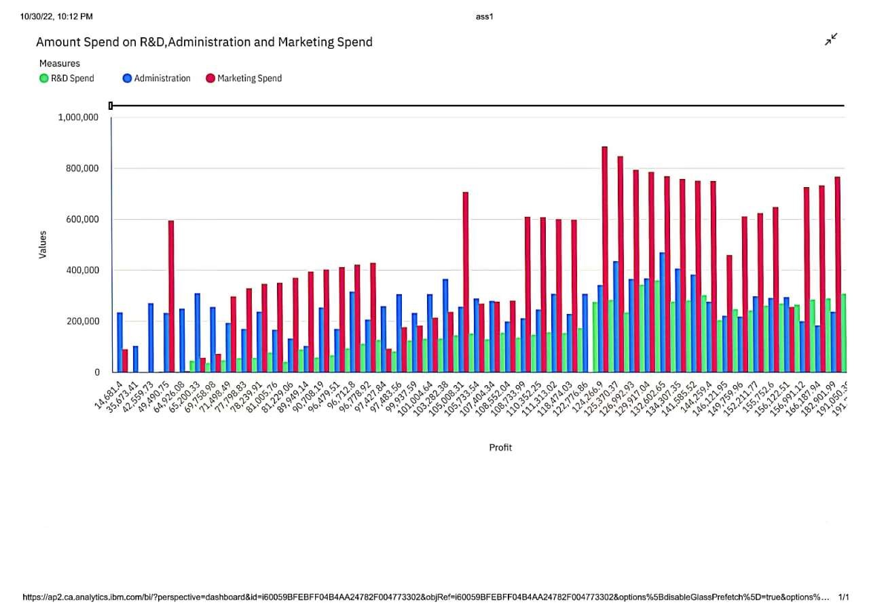

1. Research and development spread over by states.

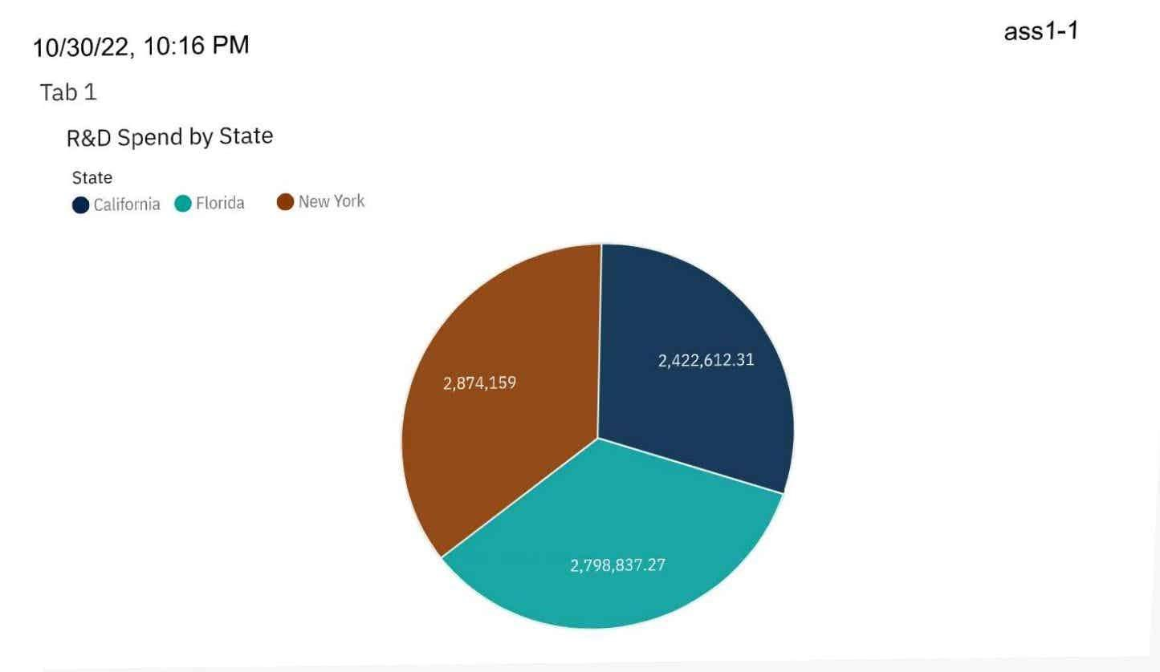

1. Research and development, Administration, Marketing spend over New York, California, and Florida.

